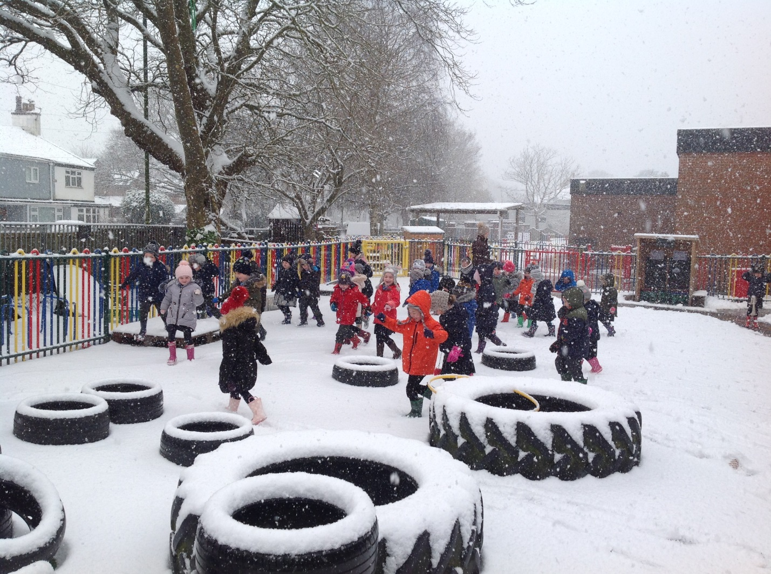
September 2024.

Early Years Foundation Stage.

What is the Early Years Foundation Stage (EYFS)?
This is a very important stage in your child’s learning and development. At Town Green we believe that our children’s early years experiences should be active, fun and secure. They should support your child’s individual development and learning needs.

What is the EYFS Framework?
The EYFS framework is a document used by all EYFS professionals. It sets out:
- The legal welfare requirements that all settings registered to look after children must follow to keep the children safe and promote their welfare.
- The 7 areas of learning and development which guide professionals to plan play activities which enable the children to develop new skills and acquire knowledge.
- Assessments which tell you about your child’s progress through the EYFS.
- Expected levels your child should reach by the end of the reception year. These expected levels are called the Early Learning Goals (ELG)

There are four underlying principles to the EYFS.
- Unique Child – recognizes that every child is a competent learner from birth who can be resilient, capable, confident and self assured.
- Positive Relationships – describes how children learn to be strong and independent from a base of loving and secure relationships.
- Enabling Environments – explains that the environment plays a key role in supporting and extending children’s development and learning.
- Learning and Development – recognizes that children develop and learn in different ways and at different rates.
These themes are used to underpin the learning and development that your child will take part in during their time in our EYFS.

What will my child be learning?
The EYFS framework explains how and what your child will be learning to support their healthy development. There are 7 areas of learning which are divided into 3 prime areas and 4 specific areas. The children will develop the three prime areas first. These are:
Communication and Language – involves providing the children with opportunities to experience a language rich environment; to develop their confidence and skills in expressing themselves and to speak and listen in a range of situations.
Physical Development – involves providing opportunities for the children to be active and interactive; to develop their co-ordination, control and movement. Children must be helped to understand the importance of physical activity and to make healthy choices in relation to food.
Personal, Social and Emotional Development – involves helping children to develop a sense of themselves and others; to form positive relationships and develop respect for each other; to develop social skills and learn how to manage their feelings; to understand appropriate behaviour in groups and to have confidence in their own abilities.

The four specific areas are:
Literacy – involves encouraging children to link sounds and letters and to begin to read and write. Children must be given access to a wide range of reading materials including books, poems and other written materials to ignite their interest.
Mathematics – involves providing opportunities to develop and improve their skills in counting, understanding and using numbers, calculating simple addition and subtraction problems and to describe shapes, spaces and measures.
Understanding the world – involves guiding children to make sense of their physical world and their community through opportunities to explore, observe and investigate people, places and their environment.

Expressive Arts and Design – involves enabling children to explore and play with a range of media and materials, as well as providing opportunities and encouragement for sharing their thoughts, ideas and feelings through a variety of activities in art, music, movement, dance, role play and design and technology.

These seven areas are used to plan your child’s learning activities. The professionals at Town Green will ensure the activities provided are suited to your child’s unique needs. Our curriculum is very flexible and we involve the children in our planning allowing their interests to lead our choice of topics.

Play is the foundation for the children’s learning. The children will develop their creative and critical thinking skills through a range of play activities which take place both indoors and outdoors.

Parents as Partners.

At Town Green we recognise parents as every child’s first and most enduring educators. We want you to be fully involved in your child’s life at Town Green and we aim to do this through:
Day to day communication – we understand that starting school is a worrying time for you and your children and we aim to make it as easy as possible. Staff are available every morning and after school and are always willing to offer advice, help and reassurance. Parents can also make appointments if they wish to discuss an issue at length.
Parents’ Evenings – We hold Parents Evenings in October/ November and February/March. We will inform you of your child’s continuing progress and invite you to see pieces of their work.
Reports – these are sent home at the end of the year (July 2025). They will include information regarding your child’s achievement in each Early Learning Goal.
Our News, Your News Books – each Friday we will send home information about what your child will be learning the following week in Literacy, Phonics, Mathematics and Topic. There is space on each page

for your child to mark make and draw (and later write) about what they have done during their weekend. The children then share their news with their key worker group on Monday afternoons.
Home/School Books - These are mainly used to record your children’s progress in reading. Please feel free to write any comments about your child’s reading at home. These books can also be used if you want to write a note to your child’s class teacher.
Phonics Book – Your child will be given a new set of sounds each week to practice saying the sound, blending the sounds and writing the sounds.
Maths Challenge Books – Each week (during the Summer Term) your child will receive a maths challenge task. These are practical tasks designed to develop your child’s skills in all areas of mathematics and for you to enjoy learning together! Again, please feel free to write a comment about how your child completed the task.
Stay and Play sessions – you are invited to come and visit our classrooms one afternoon each half term from 2.30pm to 3.30pm. During this time you are welcome to look around the classrooms, speak to staff and join your child in their play activities.

EYFS Profile.

At the end of the Reception year we complete an EYFS Profile, where we assess every child against the 17 Early Learning Goals. Throughout the year we collect information about your child’s development using an Ipad APP. This APP is specifically designed for use within schools and is secure. We will share this information with you through your child’s portfolio.
An important part of this profile is your knowledge of your child’s learning and understanding. Please let us know about any achievements your child makes outside school eg in sports clubs, drama groups, brownies etc. We value your input so please feel free to share anything you feel may be relevant.

General Information.

Water Bottles – the children are encouraged to bring a water bottle to school each day, especially during warm weather. Water bottles are available from the School Office. Please label them with your child’s name.

PE Kits – We have one PE lesson each week. PE kits are sent home at the end of each half term for washing . The children need navy shorts, black pumps (with Velcro fastening) and a school PE t-shirt. Shorts and t-shirt are available to buy online.

Jewellery – For safety reasons we ask that the children do not wear jewellery in school. This includes earrings.

School Bags – School bags are available to buy online. Please send these into school every day. Please do not use larger rucksacks etc as space in our cloakroom is limited.

Fruit – Your child may bring a piece of fresh fruit into school which they can eat at any time throughout the day. Please label all fruit pots with your child’s name. If your child brings a banana, tangerine etc please write their name on the skin or place the fruit in a labelled food bag. Each afternoon the children are offered a piece of school fruit.

Toys – The children are not encouraged to bring toys into school. We encourage them to bring topic related objects and books which they can share with their class.

