SPAR Lancashire School Games 2021
Week 2
‘Slalom Carry’ Heroes Challenge
You will need: A ball & cones. If you have no ball use a soft toy, rolled up socks and if you have no cones use soft toys, clothing, cereal boxes etc.
Scoring: You can keep your score over the next 5 weeks, as we’ll be releasing 5 rugby based challenges for you to try. Use the scoresheet on the next page to record your best score.
Video Demonstration
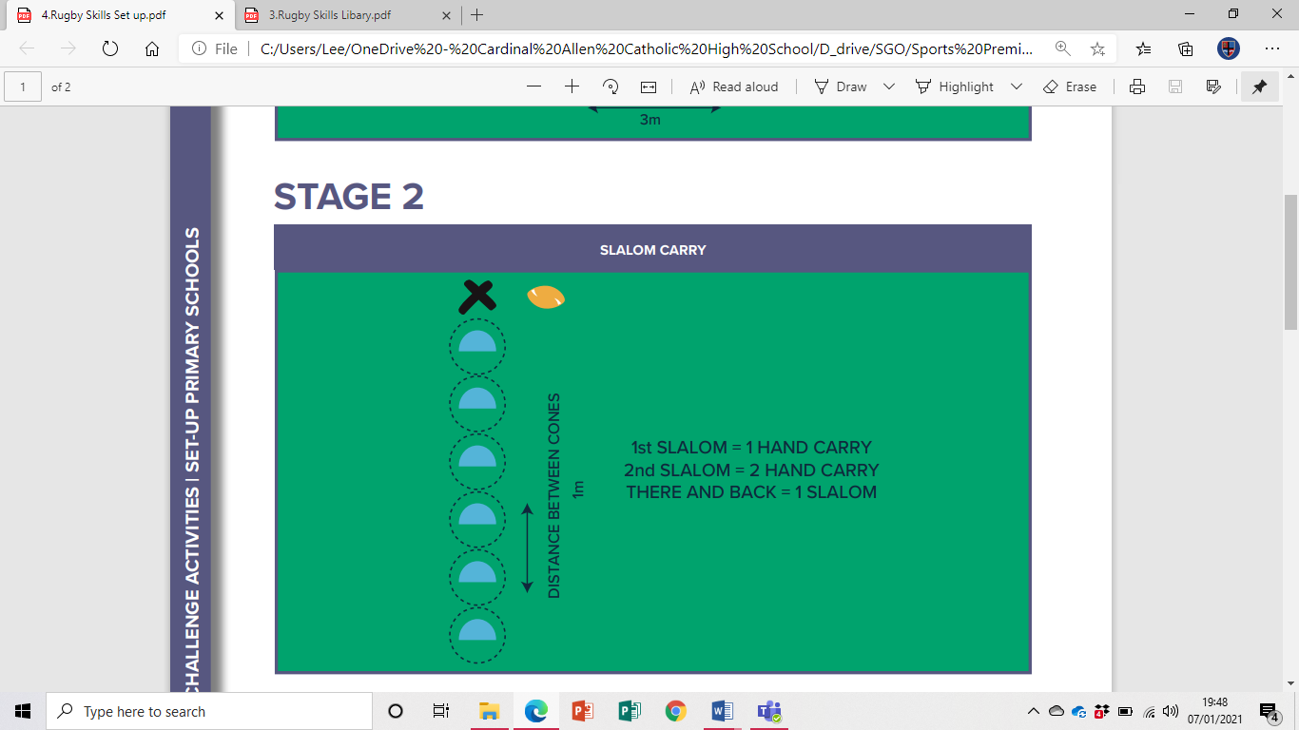
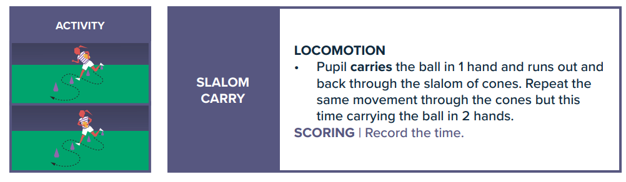
How to:


Share your videos and photos with us:

Instagram- @lancashireschoolgames Twitter- @LancSchoolGames
Facebook- @LancSchoolGames

RUGBY CHALLENGE
Challenge | Best Attempt
Week 1 – Score a Try
Week 2 – Slalom Carry
Week 3 – Colour/Number Sequence
Week 4 – Counter Balance Pick Up
Week 5 – Kick to Target
Total
SCORE SHEET
PLEASE record your scores on this sheet. Once you have completed all the challenges in week 5 Whats App your total score for the 5 Challenges to C.Hart – 07742557397 by Friday 19th March
Certificates to all entrants and medals to highest 3 scores in each year group
Videos and photos posted on social media with the #LancsGames21 will be entered into a prize draw to win some Amazon vouchers! Please let us know which district you are from.

