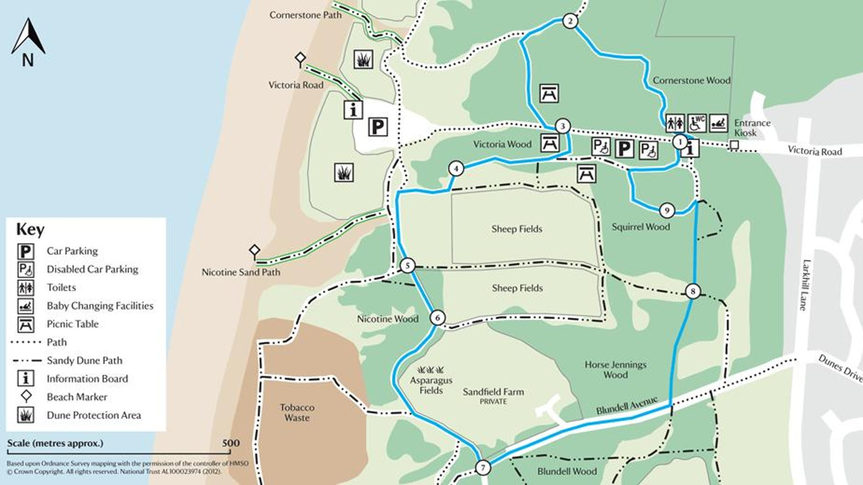

Task 1- Give directions from a chosen start to a chosen end point on the map. Aim for at least 5 detailed instructions.

Task 2- Create your own Nature Reserve map. Try to add all of the features from the key, including different paths. Make up names for any fields or streets. Write down some instructions to show how to get from a starting point to an end point on your map.



