Speed Bounce
Complete as many speed bounces as possible in 30 seconds. You could jump over a cushion or a rolled up towel.
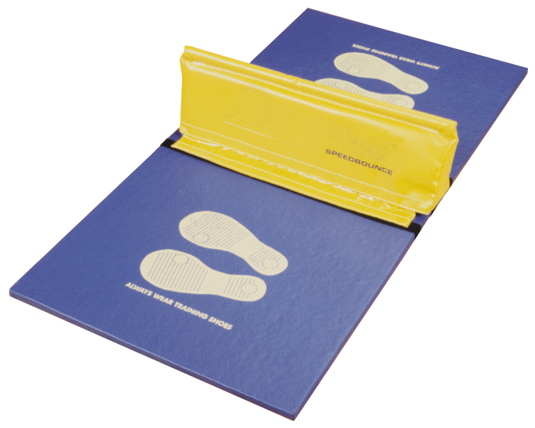

Step Ups
Complete as many ‘Step Ups’ as possible in 1 minute. To count you must place one foot on the bottom stair then step your second foot up before removing their first foot and following with their second foot (right foot up, left foot up, right foot down, left foot down = 1)
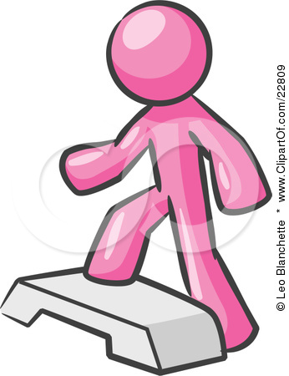

Ball Catch
Work with a partner to complete as many catches as possible in 1 minute. If you drop the ball say on catch 12, continue counting from 12 when you start again.
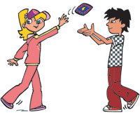

Star Jumps
Complete as many ‘Star Jumps’ as possible in 1 minute.
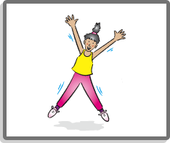

Throwing 4 Accuracy
Throw as many rolled up socks into the target as possible in 1 minute.

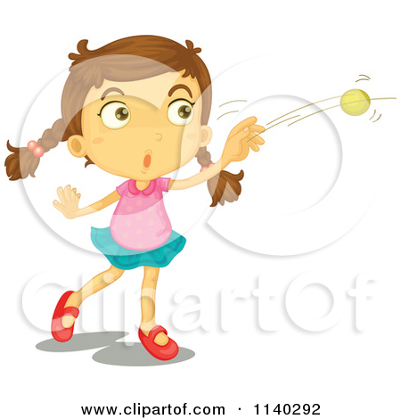

Sit Ups
Complete as many ‘Sit Ups’ as possible in 30 seconds.
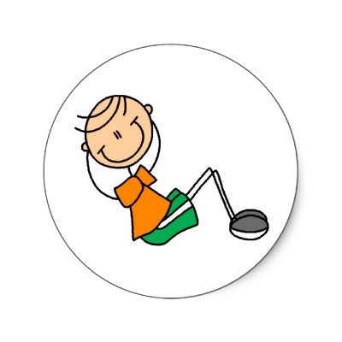

Shuttle Runs
For this task you would be better outside. Run from a starting point at one end of the garden to the other end and back. There and back is counted as 1. How many can you do in 1 minute?
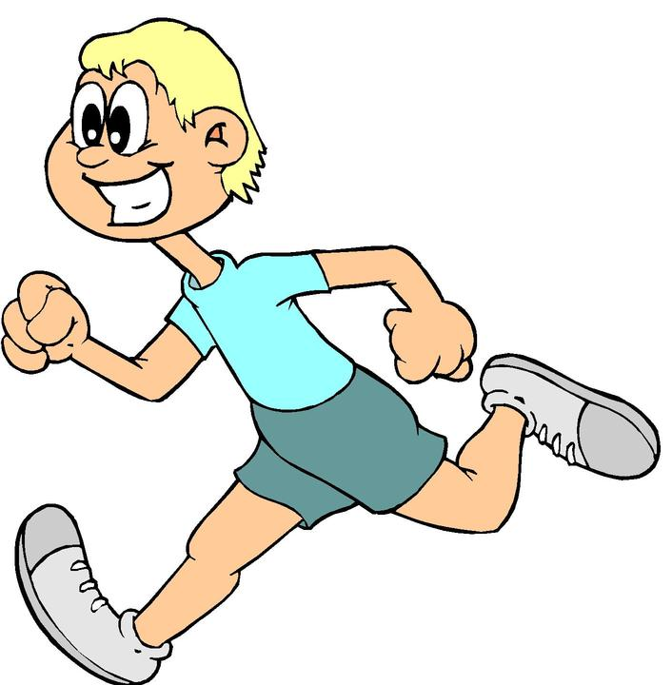

Spotty Dog
Complete as many Spotty Dogs as possible in 1 minute. Start with your right foot and left arm forward – as if about to start a running race. Alternate your legs forwards and backwards. This is running on the spot essentially, but great for co-ordination!
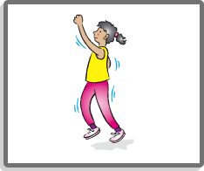

Squats
With your back against the wall, slide down so that the legs are bent and the knees are bent at 90º. Can you hold this position for 30 seconds? Each day try to hold the position a little longer. Record down how long you held the position for.
Adaptation: squat without the wall, make sure there is a straight line from ankle to knee and that bottom goes out behind the feet, back straight.
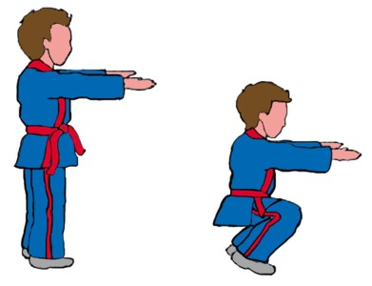
Beanbag Hold
With your arms are parallel to the floor and you have to hold the beanbags/can of beans (any can will do) up for 30 seconds. Try to hold it for a little longer each day. Record your time.
Adaption: This exercise can be made more difficult by asking the children to slowly rotate their arms!

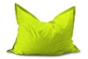

Ball head, shoulder, knees and toes.
Start with ball/cushion held above your head, then bring it down to your shoulder height, then down to your knees and finally to your toes before reversing the process. How many can you do in 1 minute?
Adaption – Use a tennis ball rather than a football


