SPAR Lancashire School Games 2021
Week 3
‘Fast Feet’ Heroes Challenge
Equipment needed; 4 hoops (if you don’t have hoop use t-shirts or jumpers).18 beanbags (use socks or other household items as alternatives). 1 cone, if you don’t have this use a tin or a soft toy). A watch, phone, clock to use as a timer.
Scoring; You can keep your score over the next 5 weeks, as we’ll be releasing 5 Netball based challenges for you to try. Use the scoresheet on the next page to record your best score.
Fast Feet Challenge Video.mp4
How to; 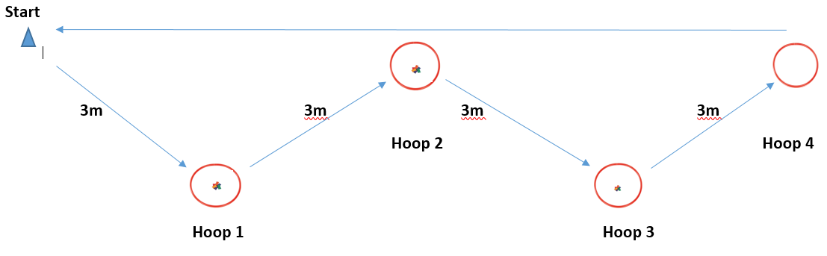What to do:
- Set the course up as above, placing 6 beanbags (or alternatives) in each of hoops 1, 2 & 3
- Player starts by the cone
- They run the zig-zag to hoops (or alternative) 1, 2 & 3 collecting 1 beanbag from each as they go and place them in hoop 4. They run round hoop 4 and straight back to the start cone. This is repeated for 30 secs
- At the end of the 30 secs the player scores a point for all the beanbags in hoop 4 and any they have in their hand
Share your videos and photos with us:
We want to see you trying this challenge at home, please share your videos and photos to;


Twitter- @LancSchoolGames

Facebook- @LancSchoolGames
Instagram- @lancashireschoolgames

NETBALL SKILLS CHALLENGE
Challenge | Best Attempt
Week 1 – Jump, Land, Balance
Week 2 – Short Pass
Week 3 – Fast Feet
Week 4 – Long Pass
Week 5 – Shoot-out
Total
SCORE SHEET
PLEASE record your scores on this sheet. Once you have completed all the challenges in week 5 Whats App your total score for the 5 Challenges to C.Hart – 07742557397 by Friday 19th March
Certificates to all entrants and medals to highest 3 scores in each year group
Videos and photos posted on social media with the #LancsGames21 will be entered into a prize draw to win some Amazon vouchers! Please let us know which district you are from.

