SPAR Lancashire School Games 2021
Week 5 (9th February 2021)
‘Kick to a Target’ Heroes Challenge
You will need: A ball (use rolled up socks as alternative) 2 cones to be a target (use a bin, clothing items). Also 3 more items for markers to change distance.
Scoring: You can keep your score over the next 5 weeks, as we’ll be releasing 5 rugby based challenges for you to try. You can submit your scores to your teacher if you like). If not, no worries, just have fun taking part.
Video Demonstration
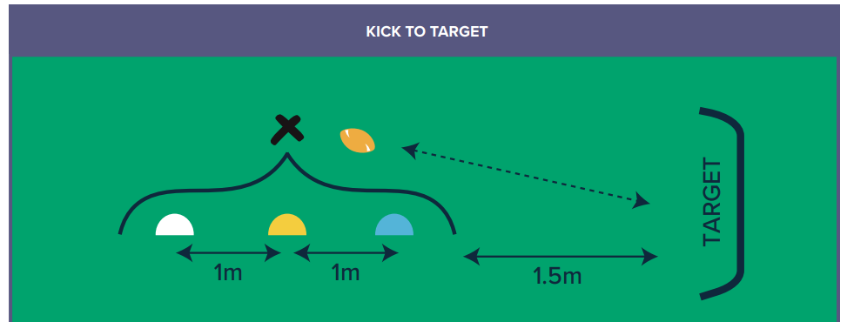
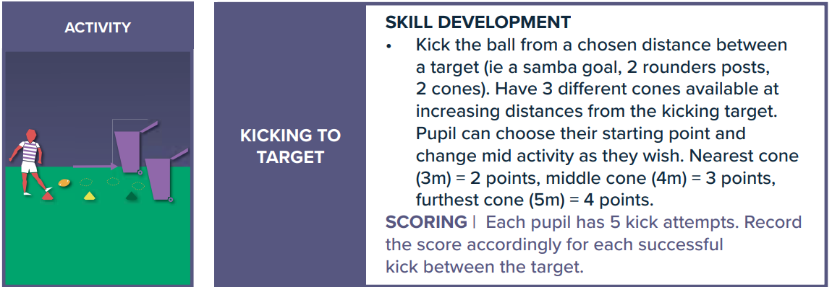
How to:
Share your videos and photos with us:


Instagram- @lancashireschoolgames

Twitter- @LancSchoolGames
Facebook- @LancSchoolGames
RUGBY CHALLENGE
Challenge | Best Attempt
Week 1 – Score a Try
Week 2 – Slalom Carry
Week 3 – Colour/Number Sequence
Week 4 – Counter Balance Pick Up
Week 5 – Kick to Target
Total
SCORE SHEET
PLEASE SUBMIT YOUR SCORE TO YOUR SCHOOL TEACHER BY 5PM ON FRIDAY 12th FEBRUARY 2021
Videos and photos posted on social media with the #LancsGames21 will be entered into a prize draw to win some Amazon vouchers! Please let us know which district you are from. By sending in your entries you are consenting to us using any videos and images. If this is not the case, please make that clear on your replies.

