SPAR Lancashire School Games 2021
Week 5 (9th February 2021)
‘Shoot Out’ Netball Heroes Challenge
Equipment needed; 1 ball (Use rolled up socks if no ball), 1 cones (use soft toys, tins If no cone), a stopwatch, clock, or phone to use as a timer. A net, hoop or mark a point on a wall and use this as your net/target.
Scoring; You can keep your score over the next 5 weeks, as we’ll be releasing 5 Netball based challenges for you to try. You can submit your scores to your teacher if you like (see next page). If not, no worries, just have fun taking part.
Shoot Out Challenge Video

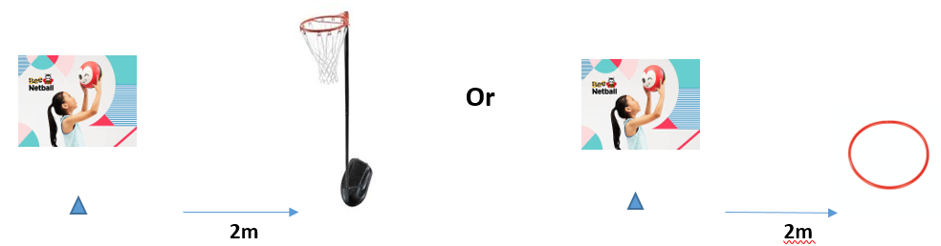
How to; What to do:
- Mark a cone 2m away from the front of the netball post (post set at:- 9ft yrs 5/6, 8ft yrs 3/4) Use hoop or focus on a mark on a wall
- Players stand by the cone and shoot the ball into the net to score
- Count the number of successful shots in 30 secs
- Schools without posts. Place a hoop 2m away from the cone. Players shoot the ball upwards and the ball must land in the hoop when it hits the floor
Share your videos and photos with us:
We want to see you trying this challenge at home, please share your videos and photos to;


Twitter- @LancSchoolGames

Facebook- @LancSchoolGames
Instagram- @lancashireschoolgames

NETBALL SKILLS CHALLENGE
Challenge | Best Attempt
Week 1 – Jump, Land, Balance
Week 2 – Short Pass
Week 3 – Fast Feet
Week 4 – Long Pass
Week 5 – Shoot-out
Total
SCORE SHEET
PLEASE SUBMIT YOUR SCORE TO YOUR SCHOOL TEACHER BY 5PM ON FRIDAY 12th FEBRUARY
Videos and photos posted on social media with the #LancsGames21 will be entered into a prize draw to win some Amazon vouchers! Please let us know which district you are from.

