SPAR Lancashire School Games 2021
Week 4
‘Long Pass’ Heroes Challenge
Equipment needed; 1 ball (Use rolled up socks if no ball), 2 cones (use soft toys, tins If no cones), a stopwatch, clock, or phone to use as a timer. 2 players (throw to a wall if you no partner)
Scoring; You can keep your score over the next 5 weeks, as we’ll be releasing 5 Netball based challenges for you to try. Use the scoresheet on the next page to record your best score.
Long Pass Challenge Video.mp4
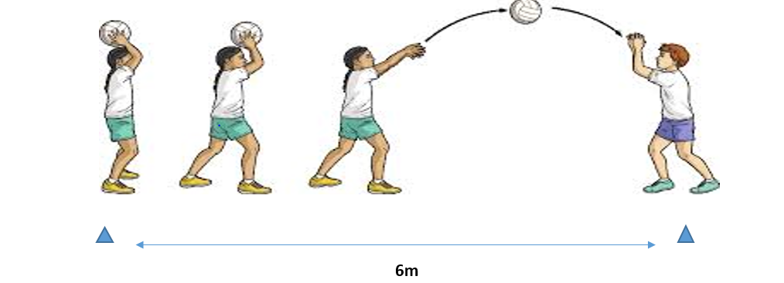
How to; What to do:
- Mark 2 cones (or alternatives) 6m apart
- Players pass the ball overhead between each other
- Count the number of passes in 30 secs
- Both players are credited with the total number of passes
Share your videos and photos with us:
We want to see you trying this challenge at home, please share your videos and photos to;


Twitter- @LancSchoolGames

Facebook- @LancSchoolGames
Instagram- @lancashireschoolgames

NETBALL SKILLS CHALLENGE
Challenge | Best Attempt
Week 1 – Jump, Land, Balance
Week 2 – Short Pass
Week 3 – Fast Feet
Week 4 – Long Pass
Week 5 – Shoot-out
Total
SCORE SHEET
PLEASE record your scores on this sheet. Once you have completed all the challenges in week 5 Whats App your total score for the 5 Challenges to C.Hart – 07742557397 by Friday 19th March
Certificates to all entrants and medals to highest 3 scores in each year group
Videos and photos posted on social media with the #LancsGames21 will be entered into a prize draw to win some Amazon vouchers! Please let us know which district you are from.

