SPAR Lancashire School Games 2021
Week 4
‘Counter Balance Pick Up Heroes Challenge
You will need: A ball (use rolled up socks as alternative) Also someone to act as a receiver from the pass.
Scoring: You can keep your score over the next 5 weeks, as we’ll be releasing 5 rugby based challenges for you to try. Use the scoresheet on the next page to record your best score.
Video Demonstration
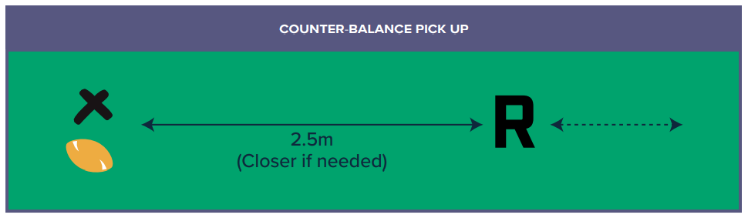
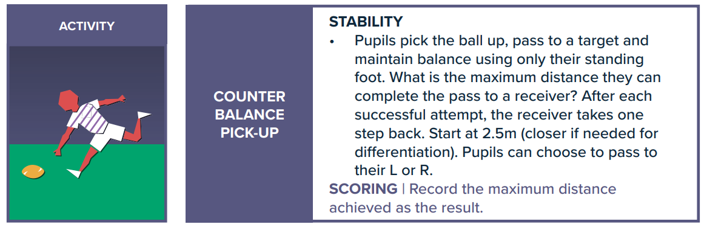
How to:
Share your videos and photos with us:


Instagram- @lancashireschoolgames

Twitter- @LancSchoolGames
Facebook- @LancSchoolGames
RUGBY CHALLENGE
Challenge | Best Attempt
Week 1 – Score a Try
Week 2 – Slalom Carry
Week 3 – Colour/Number Sequence
Week 4 – Counter Balance Pick Up
Week 5 – Kick to Target
Total
SCORE SHEET
PLEASE record your scores on this sheet. Once you have completed all the challenges in week 5 Whats App your total score for the 5 Challenges to C.Hart – 07742557397 by Friday 19th March
Certificates to all entrants and medals to highest 3 scores in each year group
Videos and photos posted on social media with the #LancsGames21 will be entered into a prize draw to win some Amazon vouchers! Please let us know which district you are from. By sending in your entries you are consenting to us using any videos and images. If this is not the case, please make that clear on your replies.

