Phonics in Year One

Phonics and reading are crucial because they provide the foundation for children to decode words, allowing them to read fluently and accurately, which is essential for accessing learning across all subjects.
In Year One, all children take the Phonics Screening Check and this year all schools must administer the test week commencing Monday 9th June 2025. It will be conducted by a class teacher from Year One in a quiet part of our school.

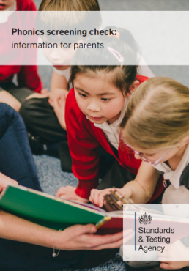
https://assets.publishing.service.gov.uk/media/676e908e517edf5c74c83728/Phonics_screening_check_information_for_parents.pdf
We recommend you read the government’s guidance in the form of a leaflet for further information.
The pass mark for the screening check in previous years has been set as 32 out of 40 words being read correctly.

What will the Phonics Check consist of?
In the Phonics Screening Check, there are a mixture of real words and pseudo (made up) words using sounds from Phases 2, 3, 4 and 5. These words vary in difficulty.
For the ‘alien’ words, there is a picture to indicate that it is not a real word. Children are to apply their knowledge of phonics to decode and blend the sounds together to read the word. If a grapheme has two pronunciations, either can be accepted e.g. the pseudo word ‘strow’ could be read with the ow (as in cow) or ow (as in snow).
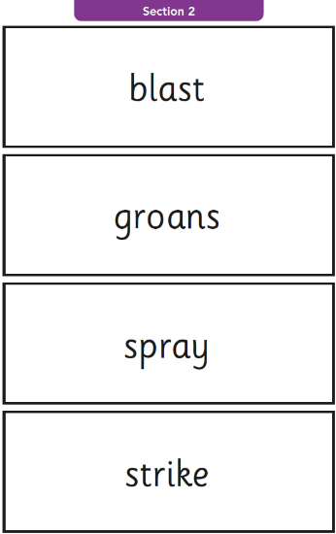
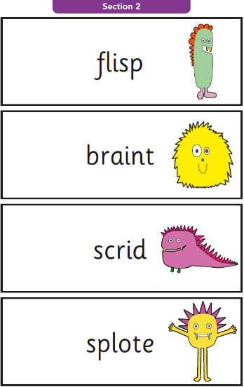
Real words do not have a picture so the children know they must blend and read a word that they know.

What do the children learn in Year 1 at Aughton Town Green?
In our phonics scheme, Little Wandle Letters and Sounds, we cover a wide range of sounds and alternative pronunciations.
The children learn how a phoneme (sound) can be made by various graphemes (spelling patterns). For example, the phoneme ‘ee’ (sheep) can be represented by ‘ea’ (each), ‘ie’ (shield), ‘e-e’ (even), ‘e’ (he) and ‘y’ (happy).
The children also learn that one grapheme (spelling pattern) can make more than one sound (phoneme). For example, ‘y’ can be pronounced ‘y’ (yoghurt), ‘ee’ (happy), igh (fly)
Please find attached a simplified set of sounds with example words that cover the main sounds covered in Year One. We hope this will help your understanding of the key sounds you can practise at home to support your child.
We will introduce the children to the concept of pseudo words after the Easter holidays.
Your child’s score from the Phonics Screening will be sent home with their end of year report. Any children who do not achieve the pass mark will continue to access our Little Wandle Letters and Sounds Phonics Programme throughout Year Two and will complete the screening in June 2026.

How can I support my child?
- Listen to your child read every day. Little and often works best. They need to practise both the book allocated each week on the Collins Hub E-reader and their shared reading book.
- Read bedtime stories to your child and encourage them to read for pleasure to develop a rich vocabulary.
- Practise the sounds on flashcards. Either write them on small pieces of paper or you can buy Little Wandle flashcards from Amazon for £6. These can then be built into words to practise reading.
- Play phonics games with your child online such as Phonics Play https://www.phonicsplay.co.uk/ or Topmarks https://www.topmarks.co.uk/english-games/5-7-years/letters-and-sounds
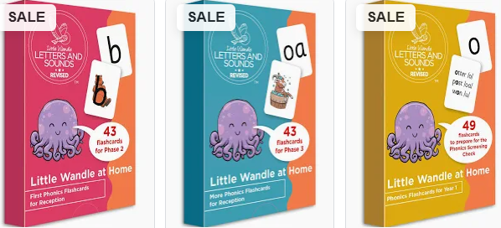
This information and the sounds overview will be on our class webpages for you to access should you need any further copies.
If you have any questions, please don’t hesitate to speak to your child's class teacher at the end of the day
Thank you for your support with your child’s reading journey,
Year One Teachers.

