Ice Balloon Instructions
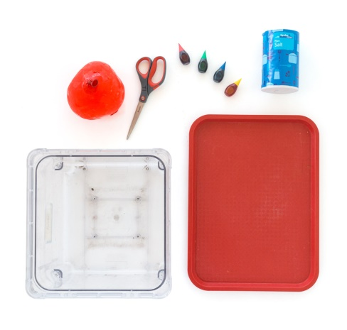
You will need;
A balloon
Tray
Food colouring (optional)
Salt
24 hours in freezer.

Instructions

- Slightly blow up a balloon then let the air out. Next fill the balloon half full of water (you can add food colouring if you wish). Tie securely, putting into additional plastic bag if you want.
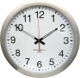
- Put into the freezer for 24 hrs.

- Once frozen remove balloon skin. Place onto a suitable container/ tray to collect the water. 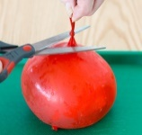

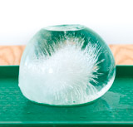
- Next sprinkle salt onto half of the ice balloon and watch what happens.

