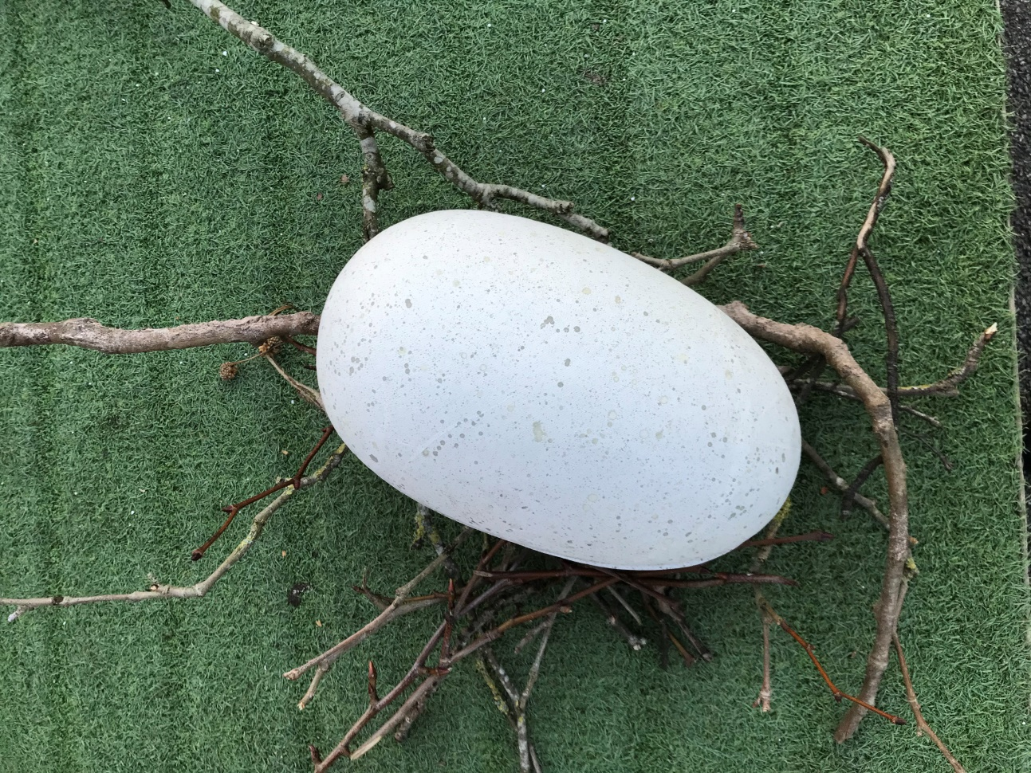
Look what Mrs Earl found on a walk.
I wonder who laid this egg?
I wonder what is inside the egg?
What do you think?

